State College Magazine
9 to 5: Erica Kaufman by Kiera Missanelli
January 2012
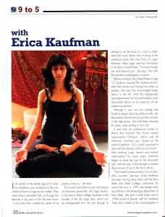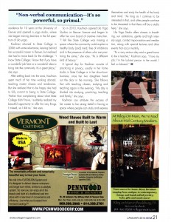

It all started at the tender age of 9 when Erica Kaufman’s mother introduced her to the non-verbal art form of yoga. They were living in Jerusalem then, and yoga has become a big part of her life ever since. “I was lucky that I tasted the nectar of its potency early on,” she says.
This month marks the two-year anniversary of Kaufman’s brainchild, Lila Yoga Studios, in downtown State College. Kaufman is the founder of the Lila yoga style, which can be distinguished from the rest through its attempt to use the body as a tool to understand the mind. Rather than thinking of the individual body, like most forms of yoga, Kaufman helps yogis sensitize themselves to all that is around them. “It moves through you and beyond you,” she says. She calls the practice a philosophy in motion.
Before moving to the United States at age 12, Kaufman enjoyed the creative environment that comes from having two artists as parents. She says they encouraged imagination in her life. With this background and appreciation for the arts Kaufman soon discovered dance as an extension of her creative movement.
Although it was not until college that Kaufman began dancing professionally, she flourished in the art form just as other women in her age group, who had been dancing for years, were starting to burn out.
It was from her professional studies in dance that Kaufman then found contact improvisation—half-sport, half-art and all American. Kaufman says “based on the external aesthetic, [it] is usually practiced in duet with the attention at the point of touch.” After studying yoga, dance and contact improvisation for many years, Kaufman began to share her love for the movement arts, and she says it has brought a tremendous amount of joy to her life to do so.
“Non-verbal communication—it’s so powerful, so primal,” she says. In fact, Kaufman has been sharing these ideas with the Penn State and State College community for some time now. In 1991 she started working full-time in the kinesiology department at Penn State. She took a brief hiatus and in 1994 moved to Denver with her husband. There she worked as the choreographer in residence for 10 years at the University of Denver and opened a yoga studio, where she began training teachers in the full spectrum of Lila yoga.
Kaufman returned to State College in 2006 with some reluctance, leaving behind her successful career in Denver, but realized she had to move back for the challenge. “I know State College; I know that if you have a wonderful job here or a wonderful idea to bring into the community it’s a great place,” she says.
After settling back into the area, Kaufman spent much of her time working abroad, teaching master classes and residencies. But she realized that to be happy she had to fully commit to being in State College. “Rather than complaining about what State College didn’t have, I suddenly realized my beautiful opportunity to offer the very things I missed, so I did so,” she says.
So in 2010, Kaufman opened Lila Yoga Studios on Beaver Avenue and began to offer her own brand of creative instruction. “I felt like State College was missing a space where the community could explore a healthy body [and] mind; free of inhibitions and in the presence of others who are practicing the same,” she says. “It’s a different kind of beauty.”
A typical day for Kaufman consists of practicing in privacy, usually in her home studio in State College or in her downtown business, once her two daughters head out the door in the morning. She follows that with teaching classes, studying and teaching again in the evening. “My day is divided into studying, practicing, teaching and family,” she says.
Kaufman can attribute the success of her career to her strong belief in having a space where people can study and express themselves and study the health of the body and mind. “As long as I continue to be interested in that, and other people continue to be interested in that there will be a studio here,” she says.
Lila Yoga Studio offers classes in breathing, sun salutations, gentle and high intensity yoga, contact improvisation and meditation, along with special lectures and other events that occur monthly.
“It’s a very serious duty and a great honor to be a teacher,” Kaufman says. “I love my job; I’m the luckiest person in the world. I feel so blessed.”

